**DOKUMENTASI CUSTUM KHANZA**

1. **Penambahan Notifikasi Daftar Ganda**

**Form : DlgReg baris 14075**

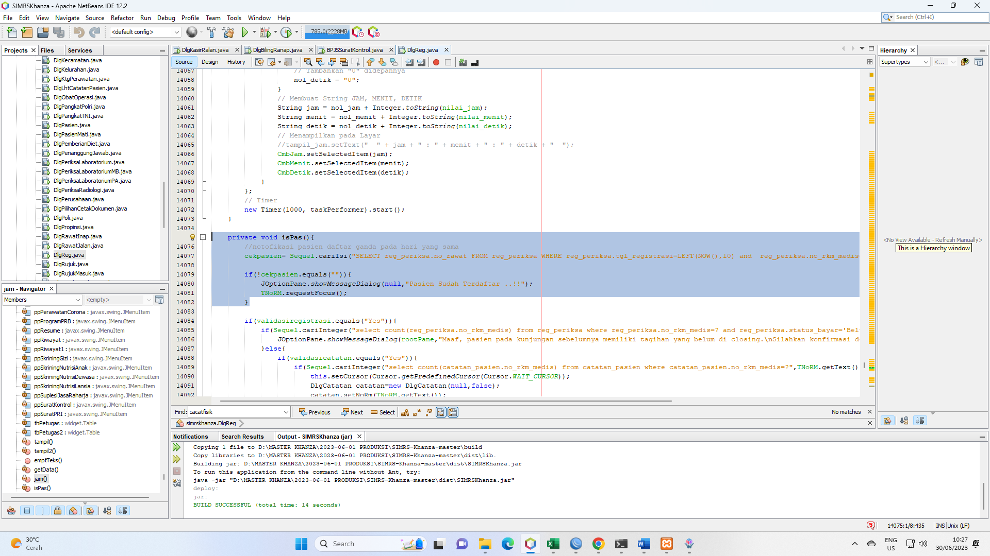

//notofikasi pasien daftar ganda pada hari yang sama

cekpasien= Sequel.cariIsi("SELECT reg_periksa.no_rawat FROM reg_periksa WHERE reg_periksa.tgl_registrasi=LEFT(NOW(),10) and reg_periksa.no_rkm_medis=?",TNoRM.getText());

if(!cekpasien.equals("")){

JOptionPane.showMessageDialog(null,"Pasien Sudah Terdaftar ..!!");

TNoRM.requestFocus();

}

1. **Penambahan Notifikasi Sisa Masa Aktif Rujukan BPJS**

**Form : BPJSSuratKontrol baris 937**

//notifikasi masa aktif rujukan pasien

sisahari= Sequel.cariInteger("SELECT (90 - DATEDIFF(CURRENT_DATE,bridging_sep.tglrujukan)) AS sisahari FROM bridging_sep WHERE bridging_sep.no_rawat =?",NoRawat.getText());

if(sisahari<=15){

JOptionPane.showMessageDialog(null,"Masa Aktif Rujukan Tersisa : "+ sisahari +" !!!");

NoRawat.requestFocus();

}

1. **Penambahan informasi Vital Sign pada Assesmen awal medis, dll**

Script:

private void isRawat() {

try {

ps=koneksi.prepareStatement(

"select reg_periksa.no_rkm_medis,pasien.nm_pasien, if(pasien.jk='L','Laki-Laki','Perempuan') as jk,pasien.tgl_lahir,reg_periksa.tgl_registrasi, "+

**"penilaian_awal_keperawatan_ralan.td,penilaian_awal_keperawatan_ralan.nadi,penilaian_awal_keperawatan_ralan.rr," +**

**"penilaian_awal_keperawatan_ralan.suhu,penilaian_awal_keperawatan_ralan.gcs,penilaian_awal_keperawatan_ralan.bb," +**

**"penilaian_awal_keperawatan_ralan.tb,penilaian_awal_keperawatan_ralan.keluhan_utama,penilaian_awal_keperawatan_ralan.rpd," +**

**"penilaian_awal_keperawatan_ralan.rpk,penilaian_awal_keperawatan_ralan.rpo,penilaian_awal_keperawatan_ralan.alergi "+**

**"from reg_periksa inner join pasien on reg_periksa.no_rkm_medis=pasien.no_rkm_medis "+**

**"inner join penilaian_awal_keperawatan_ralan on penilaian_awal_keperawatan_ralan.no_rawat=reg_periksa.no_rawat "+**

**"where reg_periksa.no_rawat=?");**

try {

ps.setString(1,TNoRw.getText());

rs=ps.executeQuery();

if(rs.next()){

TNoRM.setText(rs.getString("no_rkm_medis"));

DTPCari1.setDate(rs.getDate("tgl_registrasi"));

TPasien.setText(rs.getString("nm_pasien"));

Jk.setText(rs.getString("jk"));

TglLahir.setText(rs.getString("tgl_lahir"));

**KeluhanUtama.setText(rs.getString("keluhan_utama"));**

**RPK.setText(rs.getString("rpk"));**

**RPD.setText(rs.getString("rpd"));**

**RPO.setText(rs.getString("rpo"));**

**Alergi.setText(rs.getString("alergi"));**

**GCS.setText(rs.getString("gcs"));**

**TB.setText(rs.getString("tb"));**

**BB.setText(rs.getString("bb"));**

**TD.setText(rs.getString("td"));**

**Nadi.setText(rs.getString("nadi"));**

**RR.setText(rs.getString("rr"));**

**Suhu.setText(rs.getString("suhu"));**

1. **Edit billing ranap**

if(countbayar>1){

// if(Sequel.menyimpantf2("detail_nota_inap","?,?,?,?","Akun bayar",4,new String[]{

// TNoRw.getText(),tbAkunBayar.getValueAt(r,0).toString(),Double.toString(besarppn),Double.toString(itembayar)

// })==true){

// Sequel.menyimpan("tampjurnal","'"+tbAkunBayar.getValueAt(r,1).toString()+"','"+tbAkunBayar.getValueAt(r,0).toString()+"','"+Double.toString(itembayar)+"','0'",

// "debet=debet+"+Double.toString(itembayar),"kd_rek='"+tbAkunBayar.getValueAt(r,1).toString()+"'");

// Sequel.menyimpan("tampjurnal","'"+tbAkunBayar.getValueAt(r,1).toString()+"','"+tbAkunBayar.getValueAt(r,0).toString()+"','"+Double.toString(itembayar)+"','0'","Rekening");

// if(Host_to_Host_Bank_Jateng.equals(tbAkunBayar.getValueAt(r,1).toString())){

// if(Sequel.menyimpantf2("tagihan_bpd_jateng","?,?,?,?,?,?,?,?,?,?,?,?,?,?,?,?,''",16,new String[]{

// no_rkm_medis,nm_pasien,alamat,jk,tgl_lahir,umurdaftar,tgl_registrasi,no_nota.replaceAll("/",""),Double.toString(itembayar),"Pembayaran Pasien Rawat Inap",TNoRw.getText(),"Ranap",Valid.SetTgl(DTPTgl.getSelectedItem()+""),"Pending",akses.getkode(),"0000-00-00"

// })==true){

// sukses=false;

// }

// }

if(Sequel.menyimpantf2("detail_nota_inap","?,?,?,?","Akun bayar",4,new String[]{

TNoRw.getText(),tbAkunBayar.getValueAt(r,0).toString(),Double.toString(besarppn),Double.toString(itembayar)

})==true){

Sequel.menyimpan("tampjurnal","'"+tbAkunBayar.getValueAt(r,1).toString()+"','"+tbAkunBayar.getValueAt(r,0).toString()+"','"+Double.toString(itembayar)+"','0'","Rekening");

if(Host_to_Host_Bank_Jateng.equals(tbAkunBayar.getValueAt(r,1).toString())){

if(Sequel.menyimpantf2("tagihan_bpd_jateng","?,?,?,?,?,?,?,?,?,?,?,?,?,?,?,?,''",16,new String[]{

no_rkm_medis,nm_pasien,alamat,jk,tgl_lahir,umurdaftar,tgl_registrasi,no_nota.replaceAll("/",""),Double.toString(itembayar),"Pembayaran Pasien Rawat Ranap",TNoRw.getText(),"Ranap",Valid.SetTgl(DTPTgl.getSelectedItem()+""),"Pending",akses.getkode(),"0000-00-00"

})==false){

sukses=false;

}

}

1. **Penambahan skrip pada form DlgRawatJalan**

**Skrip digunakan untuk edit data pemeriksaaan, yakni beda user dapat melakukan edit pemeriksaan.**

if(Sequel.mengedittf("pemeriksaan_ralan","no_rawat='"+tbPemeriksaan.getValueAt(tbPemeriksaan.getSelectedRow(),1)+

"' and tgl_perawatan='"+tbPemeriksaan.getValueAt(tbPemeriksaan.getSelectedRow(),4)+

"' and jam_rawat='"+tbPemeriksaan.getValueAt(tbPemeriksaan.getSelectedRow(),5)+"'",

"no_rawat='"+TNoRw.getText()+"',suhu_tubuh='"+TSuhu.getText()+"',tensi='"+TTensi.getText()+"',"+

"keluhan='"+TKeluhan.getText()+"',pemeriksaan='"+TPemeriksaan.getText()+"',"+

"nadi='"+TNadi.getText()+"',respirasi='"+TRespirasi.getText()+"',"+

"tinggi='"+TTinggi.getText()+"',berat='"+TBerat.getText()+"',spo2='"+SpO2.getText()+"',"+

"gcs='"+TGCS.getText()+"',kesadaran='"+cmbKesadaran.getSelectedItem()+"',"+

"alergi='"+TAlergi.getText()+"',lingkar_perut='"+LingkarPerut.getText()+"',"+

"tgl_perawatan='"+Valid.SetTgl(DTPTgl.getSelectedItem()+"")+"',"+

"jam_rawat='"+cmbJam.getSelectedItem()+":"+cmbMnt.getSelectedItem()+":"+cmbDtk.getSelectedItem()+"',"+

"rtl='"+TindakLanjut.getText()+"',penilaian='"+TPenilaian.getText()+"',"+

"instruksi='"+TInstruksi.getText()+"',evaluasi='"+TEvaluasi.getText()+"'")==true){

tbPemeriksaan.setValueAt(TNoRw.getText(),tbPemeriksaan.getSelectedRow(), 1);

tbPemeriksaan.setValueAt(TNoRM.getText(),tbPemeriksaan.getSelectedRow(), 2);

tbPemeriksaan.setValueAt(TPasien.getText(),tbPemeriksaan.getSelectedRow(), 3);

tbPemeriksaan.setValueAt(Valid.SetTgl(DTPTgl.getSelectedItem()+""),tbPemeriksaan.getSelectedRow(), 4);

tbPemeriksaan.setValueAt(cmbJam.getSelectedItem()+":"+cmbMnt.getSelectedItem()+":"+cmbDtk.getSelectedItem(),tbPemeriksaan.getSelectedRow(), 5);

tbPemeriksaan.setValueAt(TSuhu.getText(),tbPemeriksaan.getSelectedRow(), 6);

tbPemeriksaan.setValueAt(TTensi.getText(),tbPemeriksaan.getSelectedRow(), 7);

tbPemeriksaan.setValueAt(TNadi.getText(),tbPemeriksaan.getSelectedRow(), 8);

tbPemeriksaan.setValueAt(TRespirasi.getText(),tbPemeriksaan.getSelectedRow(), 9);

tbPemeriksaan.setValueAt(TTinggi.getText(),tbPemeriksaan.getSelectedRow(), 10);

tbPemeriksaan.setValueAt(TBerat.getText(),tbPemeriksaan.getSelectedRow(), 11);

tbPemeriksaan.setValueAt(SpO2.getText(),tbPemeriksaan.getSelectedRow(), 12);

tbPemeriksaan.setValueAt(TGCS.getText(),tbPemeriksaan.getSelectedRow(), 13);

tbPemeriksaan.setValueAt(cmbKesadaran.getSelectedItem().toString(),tbPemeriksaan.getSelectedRow(), 14);

tbPemeriksaan.setValueAt(TKeluhan.getText(),tbPemeriksaan.getSelectedRow(), 15);

tbPemeriksaan.setValueAt(TPemeriksaan.getText(),tbPemeriksaan.getSelectedRow(), 16);

tbPemeriksaan.setValueAt(TAlergi.getText(),tbPemeriksaan.getSelectedRow(), 17);

tbPemeriksaan.setValueAt(LingkarPerut.getText(),tbPemeriksaan.getSelectedRow(), 18);

tbPemeriksaan.setValueAt(TindakLanjut.getText(),tbPemeriksaan.getSelectedRow(), 19);

tbPemeriksaan.setValueAt(TPenilaian.getText(),tbPemeriksaan.getSelectedRow(), 20);

tbPemeriksaan.setValueAt(TInstruksi.getText(),tbPemeriksaan.getSelectedRow(), 21);

tbPemeriksaan.setValueAt(TEvaluasi.getText(),tbPemeriksaan.getSelectedRow(), 22);

tbPemeriksaan.setValueAt(KdPeg.getText(),tbPemeriksaan.getSelectedRow(), 23);

tbPemeriksaan.setValueAt(TPegawai.getText(),tbPemeriksaan.getSelectedRow(), 24);

tbPemeriksaan.setValueAt(Jabatan.getText(),tbPemeriksaan.getSelectedRow(), 25);

TSuhu.setText("");TTensi.setText("");TNadi.setText("");TRespirasi.setText("");

TTinggi.setText("");TBerat.setText("");TGCS.setText("");TKeluhan.setText("");

TPemeriksaan.setText("");TAlergi.setText("");LingkarPerut.setText("");

TindakLanjut.setText("");TPenilaian.setText("");TInstruksi.setText("");

SpO2.setText("");TEvaluasi.setText("");

}

1. **Penambahan Asesesmen Medis Gigi**

Form ini duplikasi dari asesmen medis bedag mulut. Untuk table plek duplikasi medis bedah mulut, tapi direnam jadi “***penilaian_medis_ralan_gigi***”

Posisi form ada di folder rekammedis

1. Modifikasi label daftar obat **APOTEK RAWAT JALAN**

**DlgResepObat**

1. **Kasih komen, mulai baris ke 1968 - 1996**

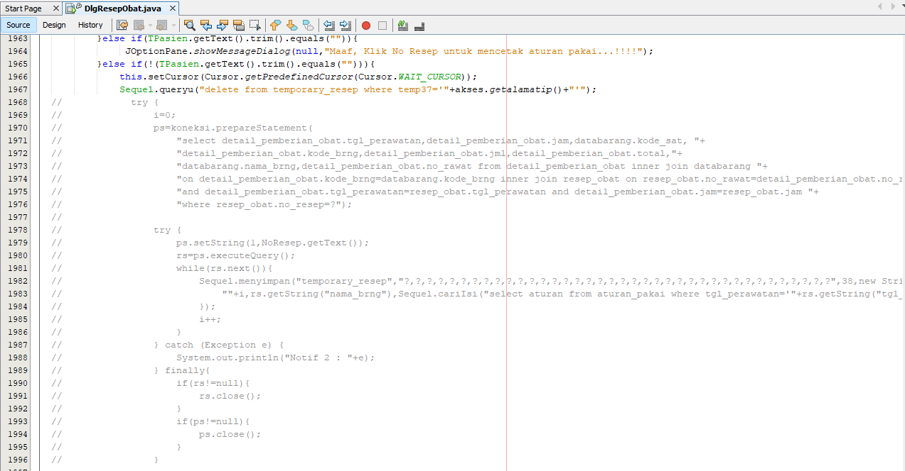

1. **Paste koding ini dibawah komen diatas**

try {

i=0;

ps=koneksi.prepareStatement(

"select databarang.nama_brng,aturan_pakai.aturan,detail_pemberian_obat.jml,kodesatuan.satuan "+

"from resep_obat inner join reg_periksa inner join "+

"aturan_pakai inner join databarang inner join detail_pemberian_obat "+

"inner join kodesatuan on resep_obat.no_rawat=reg_periksa.no_rawat "+

"and databarang.kode_brng=aturan_pakai.kode_brng and "+

"detail_pemberian_obat.kode_brng=databarang.kode_brng " +

"and resep_obat.no_rawat=aturan_pakai.no_rawat and "+

"resep_obat.tgl_perawatan=aturan_pakai.tgl_perawatan and " +

"resep_obat.jam=aturan_pakai.jam and resep_obat.no_rawat=detail_pemberian_obat.no_rawat "+

"and resep_obat.tgl_perawatan=detail_pemberian_obat.tgl_perawatan and " +

"resep_obat.jam=detail_pemberian_obat.jam and kodesatuan.kode_sat=databarang.kode_sat "+

"where resep_obat.no_resep=? and aturan_pakai.aturan<>''");//

try {

ps.setString(1,NoResep.getText());

rs=ps.executeQuery();

while(rs.next()){

Sequel.menyimpan("temporary_resep","?,?,?,?,?,?,?,?,?,?,?,?,?,?,?,?,?,?,?,?,?,?,?,?,?,?,?,?,?,?,?,?,?,?,?,?,?,?",38,new String[]{

""+i,rs.getString("nama_brng"),rs.getString("aturan"),rs.getString("jml"),rs.getString("satuan"),"","","","","","","","","","","","","","","","","","","","","","","","","","","","","","","","",akses.getalamatip()

});

i++;

}

} catch (Exception e) {

System.out.println("Notif 1 : "+e);

} finally{

if(rs!=null){

rs.close();

}

if(ps!=null){

ps.close();

}

}

psracikan=koneksi.prepareStatement(

"select obat_racikan.no_racik,obat_racikan.nama_racik,obat_racikan.tgl_perawatan,obat_racikan.jam," +

"obat_racikan.no_rawat,obat_racikan.aturan_pakai,obat_racikan.jml_dr,metode_racik.nm_racik " +

"from resep_obat inner join reg_periksa inner join " +

"obat_racikan inner join metode_racik on resep_obat.no_rawat=reg_periksa.no_rawat " +

"and obat_racikan.kd_racik=metode_racik.kd_racik " +

"and resep_obat.no_rawat=obat_racikan.no_rawat and " +

"resep_obat.tgl_perawatan=obat_racikan.tgl_perawatan and " +

"resep_obat.jam=obat_racikan.jam and resep_obat.no_rawat=obat_racikan.no_rawat "+

"where resep_obat.no_resep=?");

try {

psracikan.setString(1,NoResep.getText());

rsracikan=psracikan.executeQuery();

while(rsracikan.next()){

Sequel.menyimpan("temporary_resep","?,?,?,?,?,?,?,?,?,?,?,?,?,?,?,?,?,?,?,?,?,?,?,?,?,?,?,?,?,?,?,?,?,?,?,?,?,?",38,new String[]{

""+i,rsracikan.getString("nama_racik"),rsracikan.getString("aturan_pakai"),rsracikan.getString("jml_dr"),"","","","","","","","","","","","","","","","","","","","","","","","","","","","","","","","","",akses.getalamatip()

});

rincianobat="";

ps2=koneksi.prepareStatement(

"select databarang.nama_brng,detail_pemberian_obat.jml from "+

"detail_pemberian_obat inner join databarang inner join detail_obat_racikan "+

"on detail_pemberian_obat.kode_brng=databarang.kode_brng and "+

"detail_pemberian_obat.kode_brng=detail_obat_racikan.kode_brng and "+

"detail_pemberian_obat.tgl_perawatan=detail_obat_racikan.tgl_perawatan and "+

"detail_pemberian_obat.jam=detail_obat_racikan.jam and "+

"detail_pemberian_obat.no_rawat=detail_obat_racikan.no_rawat "+

"where detail_pemberian_obat.tgl_perawatan=? and detail_pemberian_obat.jam=? and "+

"detail_pemberian_obat.no_rawat=? and detail_obat_racikan.no_racik=? order by databarang.kode_brng");

try {

ps2.setString(1,rsracikan.getString("tgl_perawatan"));

ps2.setString(2,rsracikan.getString("jam"));

ps2.setString(3,rsracikan.getString("no_rawat"));

ps2.setString(4,rsracikan.getString("no_racik"));

rs2=ps2.executeQuery();

total=0;

while(rs2.next()){

// rincianobat=rs2.getString("nama_brng")+" "+rs2.getString("jml")+","+rincianobat;

//simpan data obat ke temp resepRes

Sequel.menyimpan("temporary_resep","?,?,?,?,?,?,?,?,?,?,?,?,?,?,?,?,?,?,?,?,?,?,?,?,?,?,?,?,?,?,?,?,?,?,?,?,?,?",38,new String[]{

""+i,rs2.getString("nama_brng"),"",rs2.getString("jml"),"","","","","","","","","","","","","","","","","","","","","","","","","","","","","","","","","",akses.getalamatip()

});

i++;

}

1. **Kasih komen**

1. Modifikasi warna Rawat Jalan
2. Penambahan script

1. Modifikasi query pada tampilan pasien rawat jalan

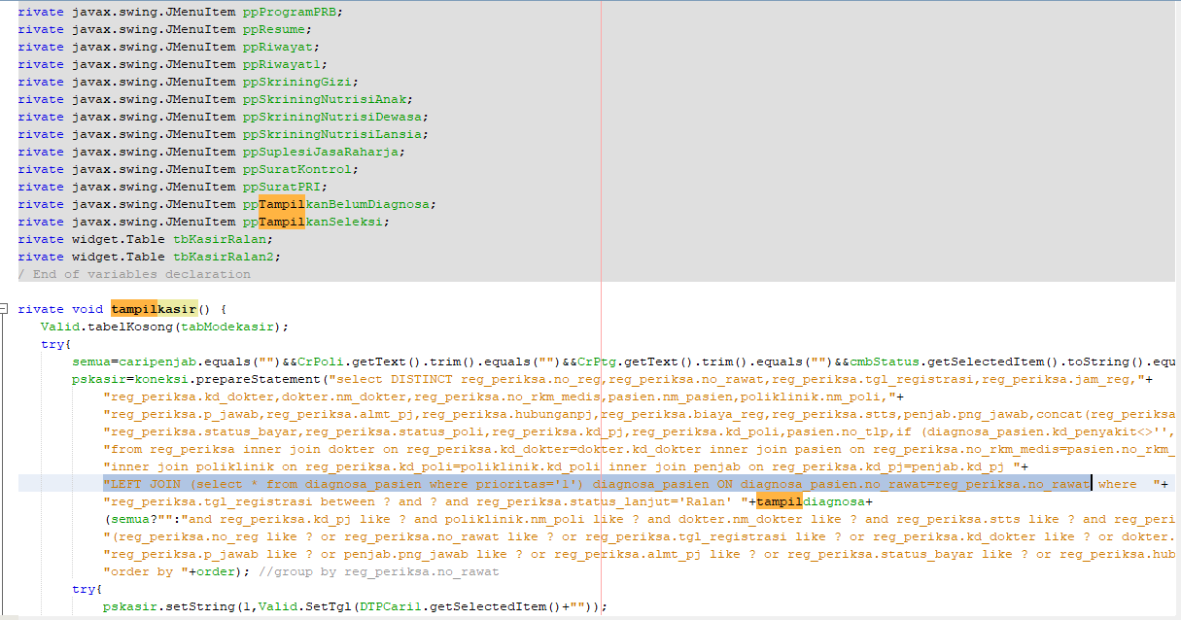

"LEFT JOIN (select * from diagnosa_pasien where prioritas='1') diagnosa_pasien ON diagnosa_pasien.no_rawat=reg_periksa.no_rawat

1. Penambahan field pada table kasir ralan

1. Sembunyikan field Diagnosa

1. a